Brown Bear News

550 MILLER LANE SEYMOUR, IN 47274 812-522-5539

March 2021

upcoming Events

Friday, March 5 – Spring Pictures

Monday, March 8 – IRead-3 begins

March 8th –12th – National School Breakfast Week

Friday, March 12 – End of 3rd grading period

Sunday, March14 – Daylight Savings Time Begins

March 22 - March 26 – Spring Break – No School



**REMINDERS**

* Send masks and water bottles

daily with students.

* Only individually packaged snacks are allowed (i.e. Little Debbie cakes)
* Make sure student’s chromebooks are fully charged and remember to send them to school daily.
* Doors open at 8:00 AM – Students need to practice social distancing while waiting to enter the building.
* Stay home if you are sick, students must be 24 hr fever/vomit free before returning to school.
* Please call the office for any absences. This includes virtual learners.
* **When parking to pick up your child, you MUST be in a parking spot. The car rider line is ONLY for car riders.**



**SPRING PICTURES**

**Spring pictures will be Friday, March 5th.**

**If you wish to order, please send the picture day envelopes with payment or order online at mylifetouch.com**

Don’t forget to check out our Title 1 March Newsletter and Recipes for Success on our school website!

## Celebrate National School Breakfast Week

## March 8-12

## Parents, your mornings are hectic and it is not

## easy to prepare a well-balanced breakfast for your

## students. Breakfast at school can help. School

## breakfast is healthier than ever! We offer fresh

## fruits, whole grains, limits on trans-fats, and

## low-fat or fat-free milk. During this week we are

## setting a goal to increase breakfast participation. If we meet our goal, our school will win a special treat of Domino’s Pizza lunch.

## All students can eat breakfast

## for FREE!



April 15, 2021

8:30 AM – 2:30 PM

4:00 – 7:00 PM

## Registration is NOT open at this time

## Forms with information regarding enrollment and requirements have been sent home with students. Please fill them out and return to the office.

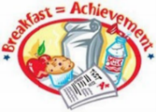

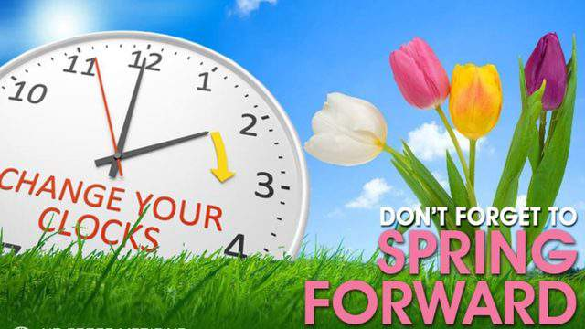

Sunday, March 14, 2021

**IRead-3 TESTING**

IRead-3 testing will be from March 8 – March 12 for 3rd graders. Please make sure students come to school every day and arrive on time. Virtual students will be notified with a schedule for testing.

Sidebar Articles

This sidebar article was created with a text box. You can use a sidebar article for any information you want to keep separate from other articles or information that highlights an article next to it. These could include a list of contributors, addresses or contact information, a smaller self-contained story, a preview of the next issue, or a calendar of schedule. The example below shows a Calendar of Events.

continued from page 1

Inserting and Editing Pictures

Type your sub-heading here

You can replace the pictures in this template with your company’s art. Select the picture you want to replace, point to Picture in the Insert menu, and click From File. Choose a new picture and then click Insert. Select the Link to File box if you don’t want to embed the art in the newsletter. This is a good idea if you need to minimize your file size; embedding a picture adds significantly to the size of the file.

To edit a picture, click on it to activate the Picture toolbar. You can use this toolbar to adjust brightness and contrast,

Choose a new picture, and click the Link to File box if you don’t want to save the art with the newsletter.

change line properties and crop the image. For more detailed editing, double-click on the graphic to activate the drawing layer. ◼

More Ways to Customize This Template

Footers

To change the text at the very bottom of each page of your newsletter, click Headers and Footers on the View menu. Use the Header and Footer toolbar to open the footer, and replace the sample text with your own text.

Insert Symbol

It is a good idea to place a small symbol at the end of each article to let the reader know that the article is finished and will not continue onto another page. Position your cursor at the end of the article, click Symbol on the Insert menu, choose the symbol you want, and then click Insert.

Borders

You can use page borders and text box borders to change the appearance of your newsletter. Borders on text boxes help keep different articles separate, and can set off sidebar articles from the rest of the page. To change a text box border, select it, double click its edge and choose the Colors and Lines tab in the Format Auto Shape dialog box.

Questions and Answers

Q: I would like to change some of the text box shading to improve the print quality. Can that be done?

A: Yes. To change the shading or color of a text box, select it and double click its borders to open the Format Text Box dialog box. Click the colors and lines tab and then choose the new color from the Color drop-down list in the Fill section.

Q: What’s the best way to print this newsletter?

A: Print page 2 on the back of page 1.Fold in half and mail with or without an envelope. For best results, use a medium to heavyweight paper. If you’re mailing without an envelope, seal with a label.

Q: I would like to use my own clip art. How do I change the art without changing the design?

A: To change a picture, click on the picture, then point to Picture on the Insert menu and click From File. Choose a new picture, and click Insert.

Q: How do I change the text and borders that appear at the bottom of every page?

A: Click Headers and Footers on the View menu. Use the Header and Footer toolbar to navigate among headers and footers, insert date or time, or format the page numbers. To change the text in the footer, select it and type your new text. To change the border, click Borders and Shading on the Format menu.

Q: Can I save a customized newsletter as a template for future editions?

A: Yes. First make any changes you want to this newsletter, then click Save As on the File menu. Choose Document Template from the Save as type drop down list (the extension should change from .doc to .dot). Save the file under a new name. Next time you want to create a newsletter, choose New from the File menu, then choose your template.