https://lh5.googleusercontent.com/nNcwmFqRBfcKubxEohRJAy-Rl5XOQxXHPxajn_1cidSG1qktuioB8nr6PEjQA4e31CJup0lrbi_iZiddgLZ0RK5jjNe5gLDh4fj5l7AOoMi4QBTwJ59Q7-z9XCL8RlbVMG94zAseBrown Bear News

550 MILLER LANE SEYMOUR, IN 47274 812-522-5539

October 2021

**Online Book Fair**

**September 27 – October 10**

Our Scholastic book fair this year will be online. Preview flyers were sent home with students this week. Support our school by shopping at <https://www.scholastic.com/bf/brownelementaryschool43>.

**All orders will be shipped home.**

Upcoming Events

Sept. 27 – Oct. 10 – Online Book Fair

Oct. 11 – Oct. 12 – eLearning Days

Oct. 13 – Oct. 15 – Fall Break – No School

Oct. 18 – Oct. 22 – Title 1 Virtual Family Event

Oct. 18 – Oct. 22 – Penny Wars

Oct. 25 – Oct. 29 – Red Ribbon Week

Week of Oct. 25 – Girls Basketball Try Outs



**RED RIBBON WEEK 2021**

**Monday 10/25**

**Brown Bears are proud to be Drug Free!**

**Wear Red to kick off RED RIBBON WEEK!**

**Tuesday 10/26**

**Brown Bears will Team Up Against Drugs**

**Wear your favorite sports gear!**

**Wednesday 10/27**

**We are too smart to get “tied-up” with drugs.  Wear tie-dye.**

**Thursday 10/28**

**Black out Drugs – Just say NO!**

**Everyone wear black!**

**Friday 10/29**

**Brown Bears Are Proud to Be Drug Free**

**Wear School colors / Brown Bear Spirit Wear**

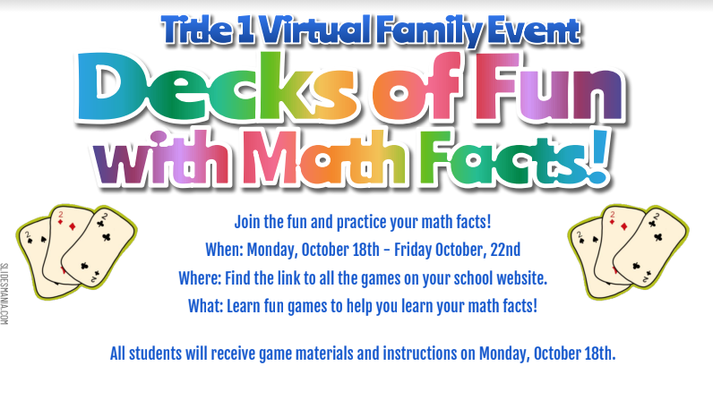



## eLearning Days

October 11 – October 12 are scheduled eLearning days for Seymour Community Schools.

On eLearning days, students do not come to school in person and will complete their school work from home. Teachers will post work on their Google Classroom and/or send work for students to complete and return when they return to school.

October 13

Through

October 15

PENNY WARS

Seymour High School’s Dance Marathon Committee works throughout the year to raise money for Riley Hospital for Children through various fundraising efforts. This year, they are hoping to raise at least $11,500, which would bring their seven-year total to $100,000 raised for the kids. To help reach this goal, the week of October 18th all the elementary schools will be hosting a Penny War.  Throughout the week students will be encouraged to bring in coins to raise money for Riley Children's Hospital.

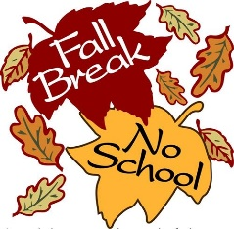

continued from page 1

Inserting and Editing Pictures

Type your sub-heading here

You can replace the pictures in this template with your company’s art. Select the picture you want to replace, point to Picture in the Insert menu, and click From File. Choose a new picture and then click Insert. Select the Link to File box if you don’t want to embed the art in the newsletter. This is a good idea if you need to minimize your file size; embedding a picture adds significantly to the size of the file.

To edit a picture, click on it to activate the Picture toolbar. You can use this toolbar to adjust brightness and contrast,

Choose a new picture, and click the Link to File box if you don’t want to save the art with the newsletter.

change line properties and crop the image. For more detailed editing, double-click on the graphic to activate the drawing layer. ◼

More Ways to Customize This Template

Footers

To change the text at the very bottom of each page of your newsletter, click Headers and Footers on the View menu. Use the Header and Footer toolbar to open the footer, and replace the sample text with your own text.

Insert Symbol

It is a good idea to place a small symbol at the end of each article to let the reader know that the article is finished and will not continue onto another page. Position your cursor at the end of the article, click Symbol on the Insert menu, choose the symbol you want, and then click Insert.

Borders

You can use page borders and text box borders to change the appearance of your newsletter. Borders on text boxes help keep different articles separate, and can set off sidebar articles from the rest of the page. To change a text box border, select it, double click its edge and choose the Colors and Lines tab in the Format Auto Shape dialog box.

Questions and Answers

Q: I would like to change some of the text box shading to improve the print quality. Can that be done?

A: Yes. To change the shading or color of a text box, select it and double click its borders to open the Format Text Box dialog box. Click the colors and lines tab and then choose the new color from the Color drop-down list in the Fill section.

Q: What’s the best way to print this newsletter?

A: Print page 2 on the back of page 1.Fold in half and mail with or without an envelope. For best results, use a medium to heavyweight paper. If you’re mailing without an envelope, seal with a label.

Q: I would like to use my own clip art. How do I change the art without changing the design?

A: To change a picture, click on the picture, then point to Picture on the Insert menu and click From File. Choose a new picture, and click Insert.

Q: How do I change the text and borders that appear at the bottom of every page?

A: Click Headers and Footers on the View menu. Use the Header and Footer toolbar to navigate among headers and footers, insert date or time, or format the page numbers. To change the text in the footer, select it and type your new text. To change the border, click Borders and Shading on the Format menu.

Q: Can I save a customized newsletter as a template for future editions?

A: Yes. First make any changes you want to this newsletter, then click Save As on the File menu. Choose Document Template from the Save as type drop down list (the extension should change from .doc to .dot). Save the file under a new name. Next time you want to create a newsletter, choose New from the File menu, then choose your template.