https://lh5.googleusercontent.com/nNcwmFqRBfcKubxEohRJAy-Rl5XOQxXHPxajn_1cidSG1qktuioB8nr6PEjQA4e31CJup0lrbi_iZiddgLZ0RK5jjNe5gLDh4fj5l7AOoMi4QBTwJ59Q7-z9XCL8RlbVMG94zAseBrown Bear News

550 MILLER LANE SEYMOUR, IN 47274 812-522-5539

March 2022

Upcoming Events

March 6-10 – National Social Workers Week

March 7–11 - National School Breakfast Week

March 8- 9 - IREAD 3 (2nd and 3rd grade)

March 10 – Title 1 Spring Event 5:00-6:15 pm

March 12 – BB trip to Medora Timber Jacks

March 13 – Daylight Savings

March 15 – 3rd Grade Spring Program 6:00 pm

March 18 – Yearbook Orders due

March 21 – 25 Spring Break – No School

**March Guidance Lessons with Mrs. Munson**

**Topic: Careers**

We will be talking about our hopes and dreams for the future! Dream Big

And

Always Believe in Yourself!

**REMINDERS**

* Sign up to receive text alerts through school messenger. Send “Y” or “Yes” to 67587 to receive information about events, school closing and more.

* Masks are now optional, with the exception on busses. If you would like your child to wear a mask, please send one from home.

*Don’t forget to order your yearbook. Visit Lifetouch.com or send $15 to the school.

* If you pick up your child in the car rider line, you must stay in the line at all times.

*Make sure you are calling before 10:30 AM and letting the office know about any absences.

*Lost & Found – Please have students check the lost & found in the cafeteria. We have many unclaimed coats and belongings.

**Camp-Read-A Lot**

A Title 1 Family Event of reading activities for the whole family

When: Thursday, Mar. 10

Time: 5:00 pm

Place: Brown Elementary

We look forward to seeing your family there!



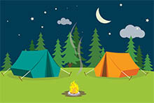



"The Time is Right; Mrs. Munson helps us Shine Bright"

**Help us Celebrate Mrs. Munson for**

**National Social Worker’s Week Mar. 6-10th**

Students will share how Mrs. Munson helps them shine bright (be the best they can be) and comments will be shared on daily announcements.

The color this year for National Social Workers is **Green**. All Brown Bears and Staff will wear green on Tues. 3/7.

**March 21 - 25**

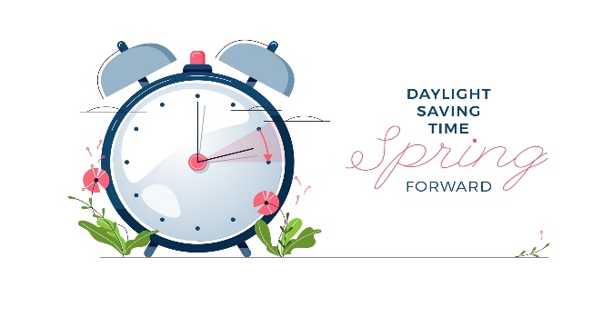

March 13, 2022

Inserting and Editing Pictures

Type your sub-heading here

You can replace the pictures in this template with your company’s art. Select the picture you want to replace, point to Picture in the Insert menu, and click From File. Choose a new picture and then click Insert. Select the Link to File box if you don’t want to embed the art in the newsletter. This is a good idea if you need to minimize your file size; embedding a picture adds significantly to the size of the file.

To edit a picture, click on it to activate the Picture toolbar. You can use this toolbar to adjust brightness and contrast,

Choose a new picture, and click the Link to File box if you don’t want to save the art with the newsletter.

change line properties and crop the image. For more detailed editing, double-click on the graphic to activate the drawing layer. ◼

More Ways to Customize This Template

Footers

To change the text at the very bottom of each page of your newsletter, click Headers and Footers on the View menu. Use the Header and Footer toolbar to open the footer, and replace the sample text with your own text.

Insert Symbol

It is a good idea to place a small symbol at the end of each article to let the reader know that the article is finished and will not continue onto another page. Position your cursor at the end of the article, click Symbol on the Insert menu, choose the symbol you want, and then click Insert.

Borders

You can use page borders and text box borders to change the appearance of your newsletter. Borders on text boxes help keep different articles separate, and can set off sidebar articles from the rest of the page. To change a text box border, select it, double click its edge and choose the Colors and Lines tab in the Format Auto Shape dialog box.

Questions and Answers

Q: I would like to change some of the text box shading to improve the print quality. Can that be done?

A: Yes. To change the shading or color of a text box, select it and double click its borders to open the Format Text Box dialog box. Click the colors and lines tab and then choose the new color from the Color drop-down list in the Fill section.

Q: What’s the best way to print this newsletter?

A: Print page 2 on the back of page 1.Fold in half and mail with or without an envelope. For best results, use a medium to heavyweight paper. If you’re mailing without an envelope, seal with a label.

Q: I would like to use my own clip art. How do I change the art without changing the design?

A: To change a picture, click on the picture, then point to Picture on the Insert menu and click From File. Choose a new picture, and click Insert.

Q: How do I change the text and borders that appear at the bottom of every page?

A: Click Headers and Footers on the View menu. Use the Header and Footer toolbar to navigate among headers and footers, insert date or time, or format the page numbers. To change the text in the footer, select it and type your new text. To change the border, click Borders and Shading on the Format menu.

Q: Can I save a customized newsletter as a template for future editions?

A: Yes. First make any changes you want to this newsletter, then click Save As on the File menu. Choose Document Template from the Save as type drop down list (the extension should change from .doc to .dot). Save the file under a new name. Next time you want to create a newsletter, choose New from the File menu, then choose your template.